**Spring boot:**

Spring boot provides abstraction on spring.

Here developers no need do any configurations

Dependency Injection:

If Bean depends on any other bean . IOC container injects that dependency object to dependent object

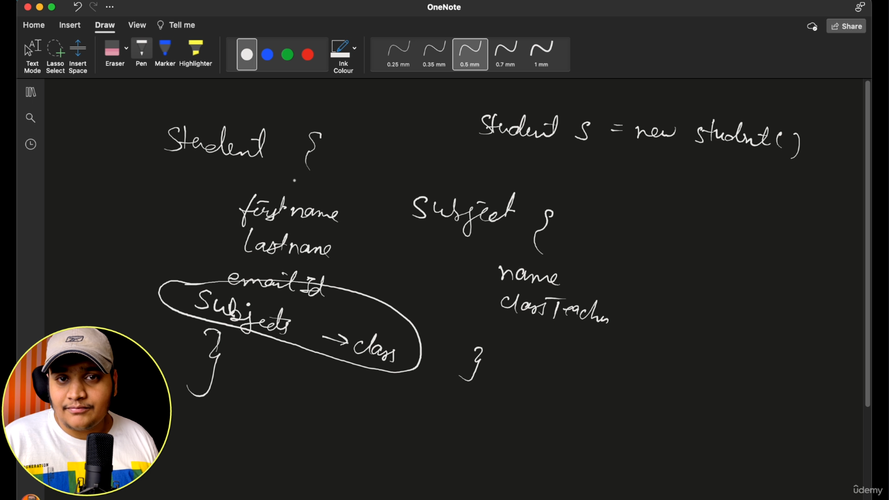

Spring io :

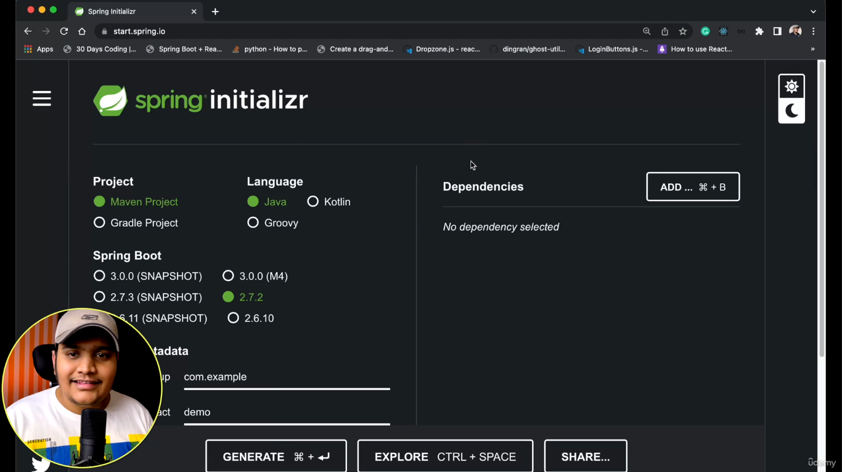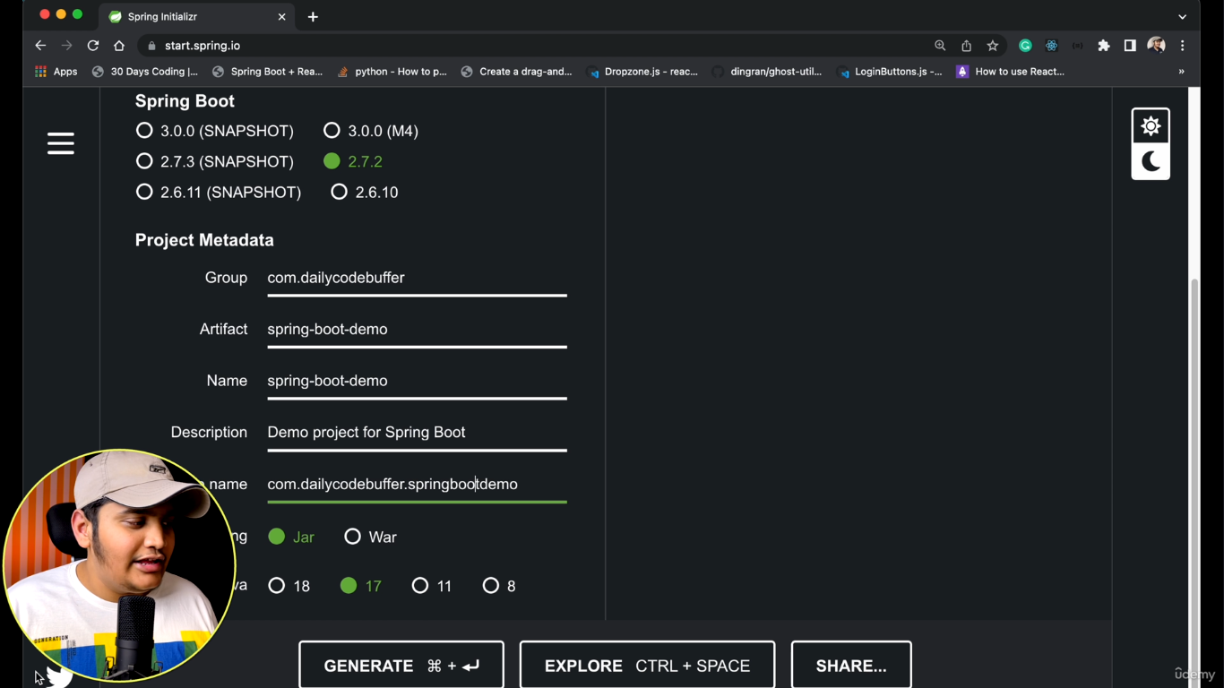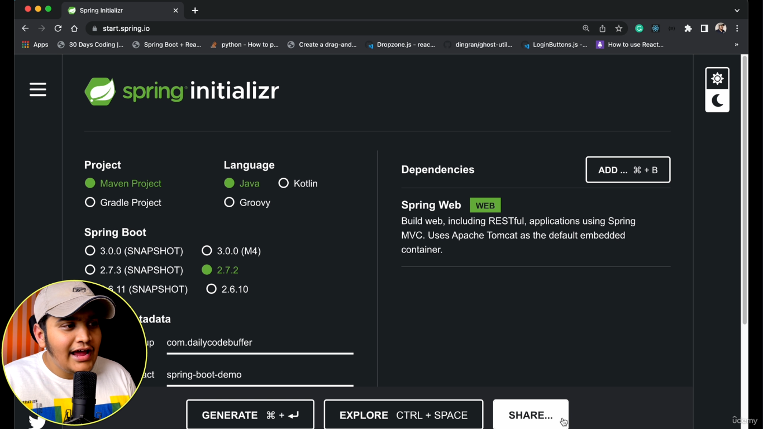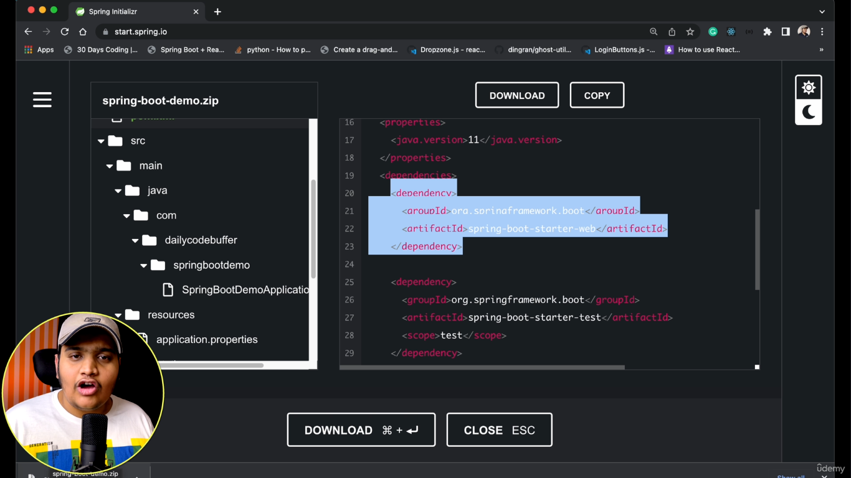

Import downloaded project into eclipse

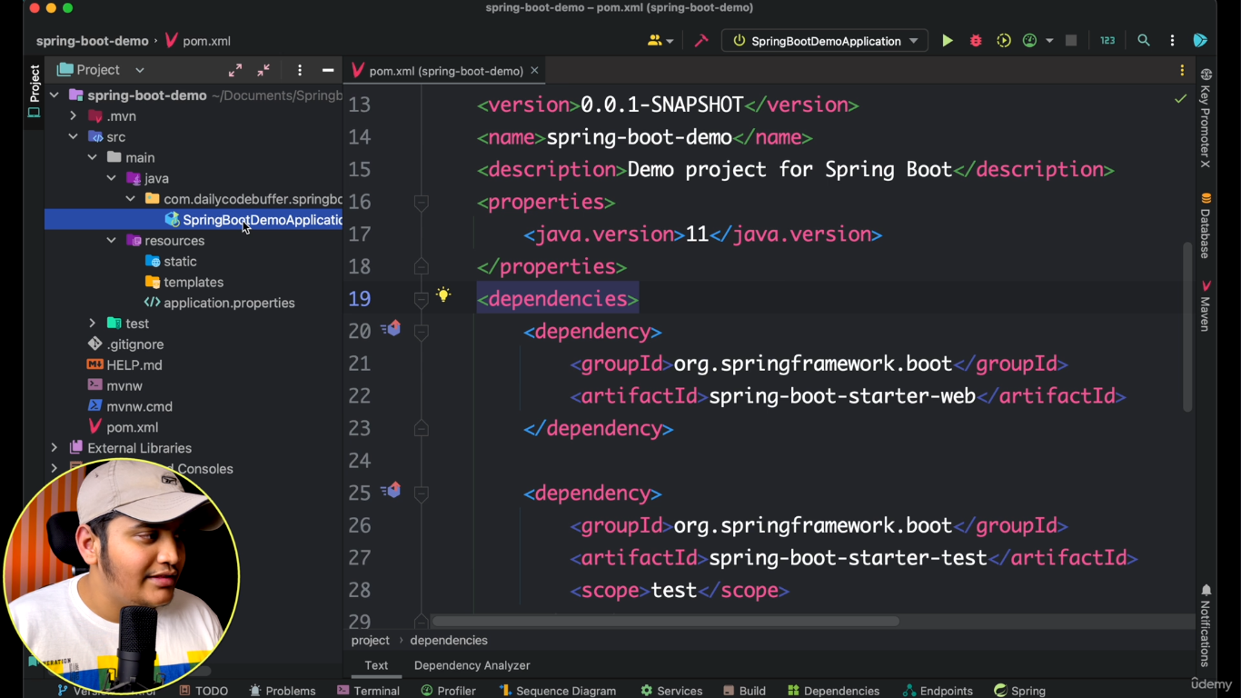

First App: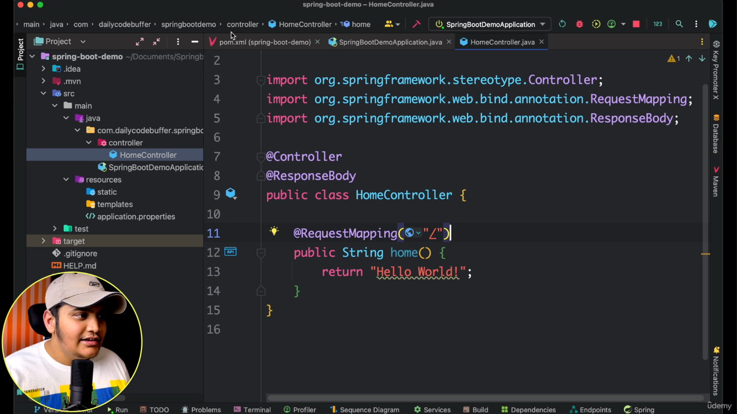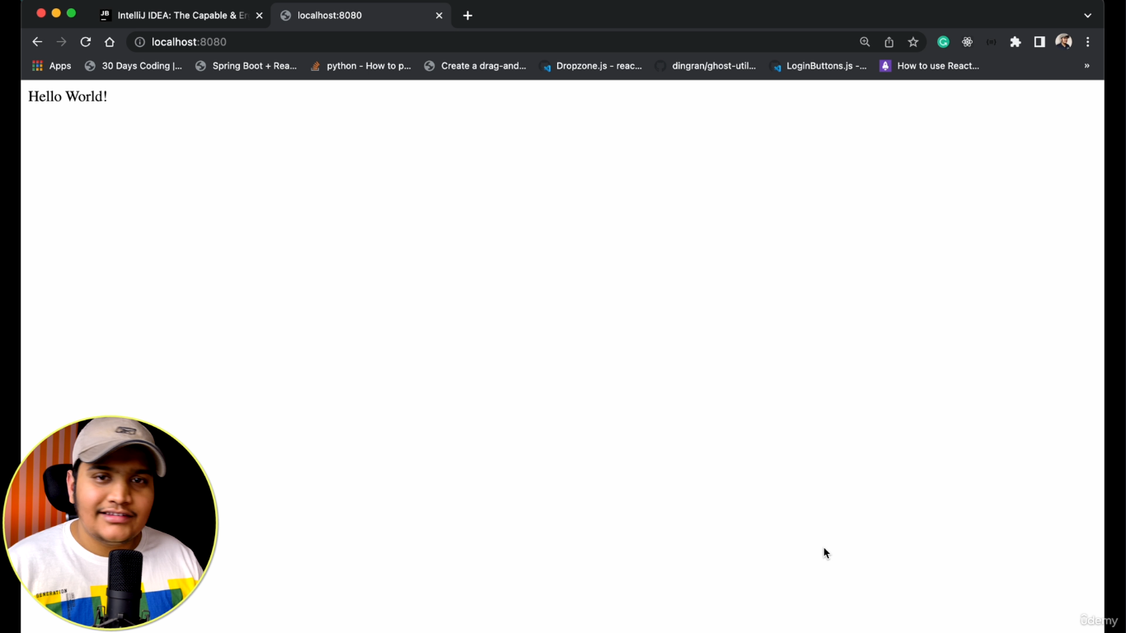

Spring boot starter:

Spring boot starter is contains the bundle of dependencies like tomcat,webmvc,web. In pom.xml open declare the spring boot starter then you can see the dependencies.

Every thing will starts from @springbootapplication. And we have run method used to start application.

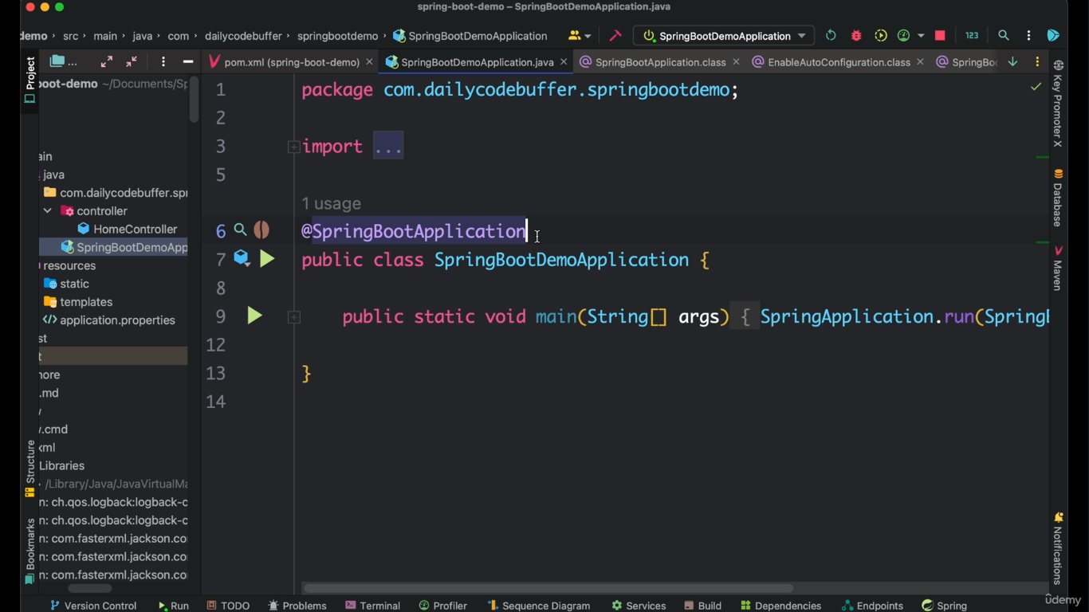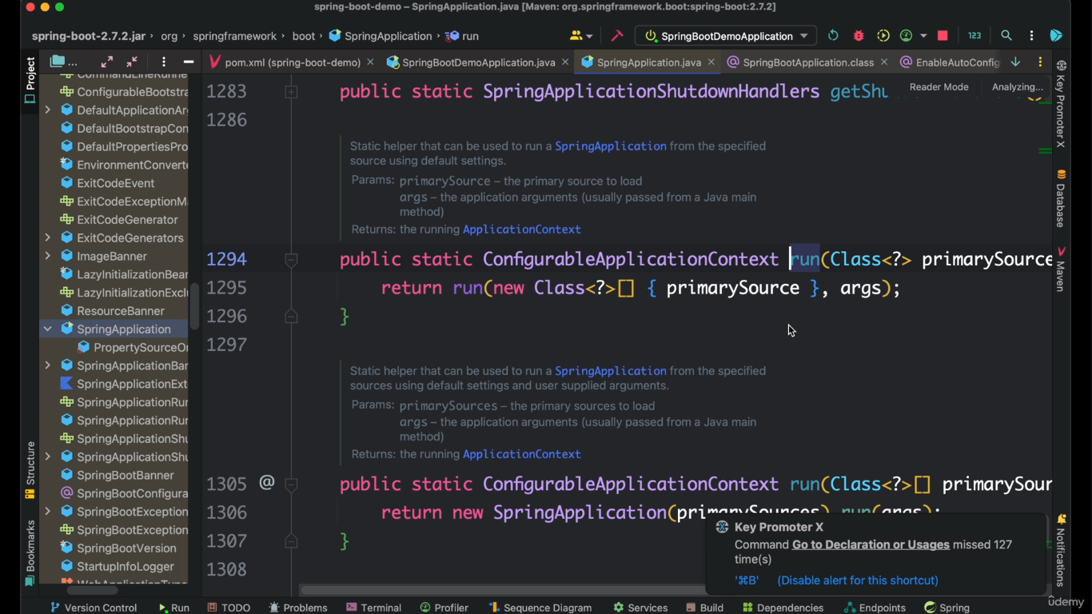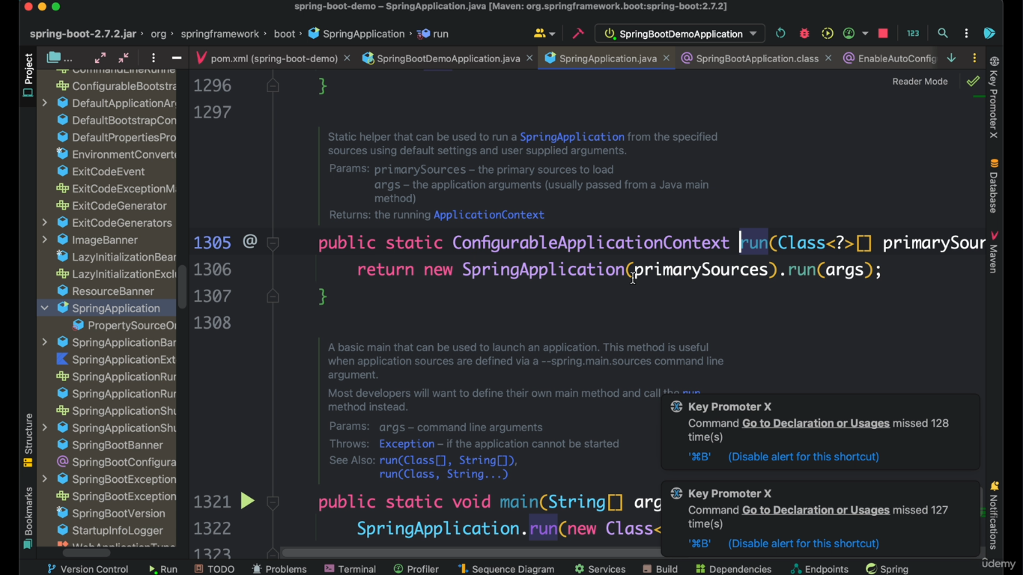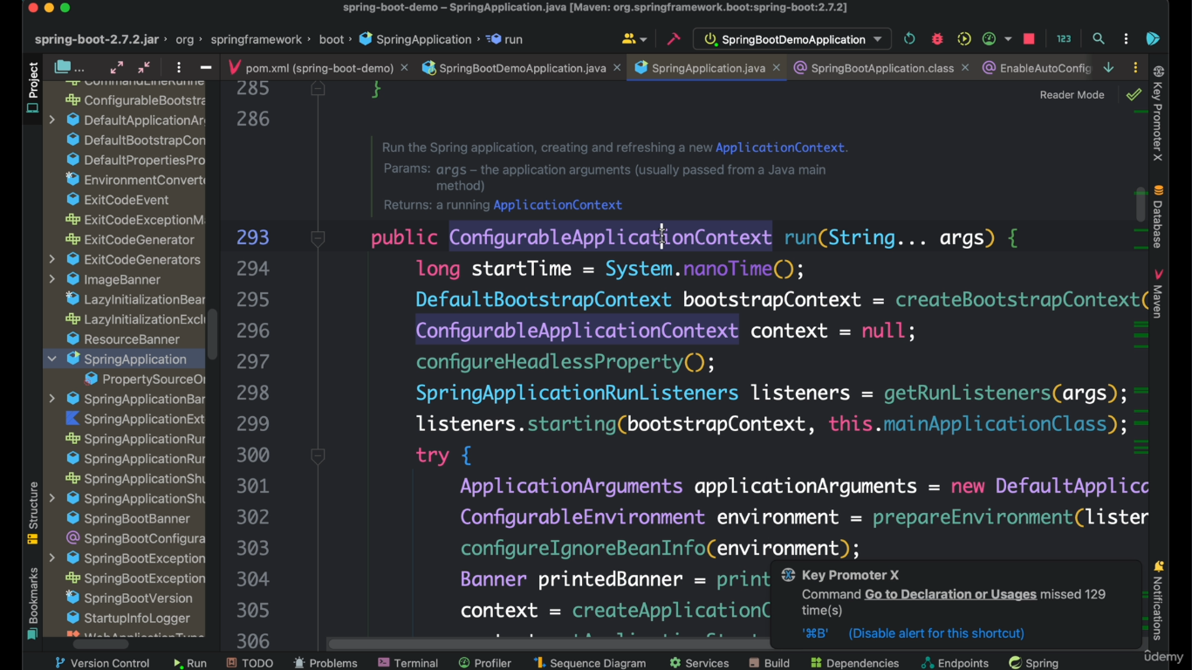

Run method return application context that contains all the beans

Before spring boot we have to deploy war file to server(tomcat or weblogic or jboss). show in below

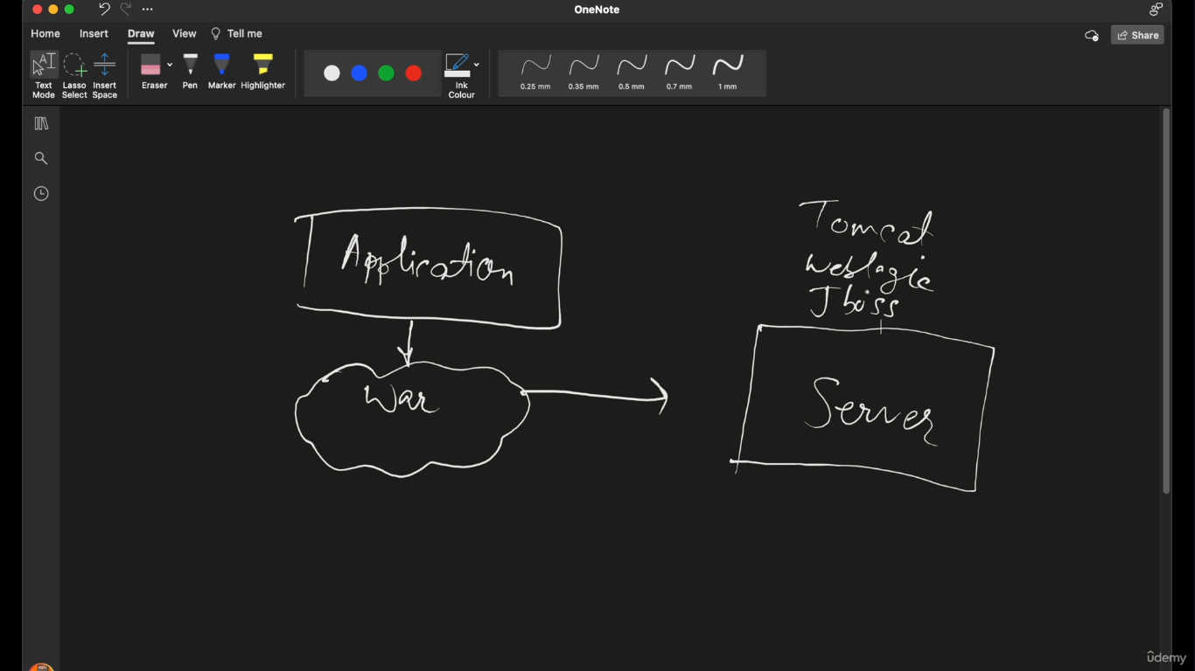

But in spring boot both Application+server(tomcat,jetty,undertow) will come in jar file. And we have to just run the application.show in below.

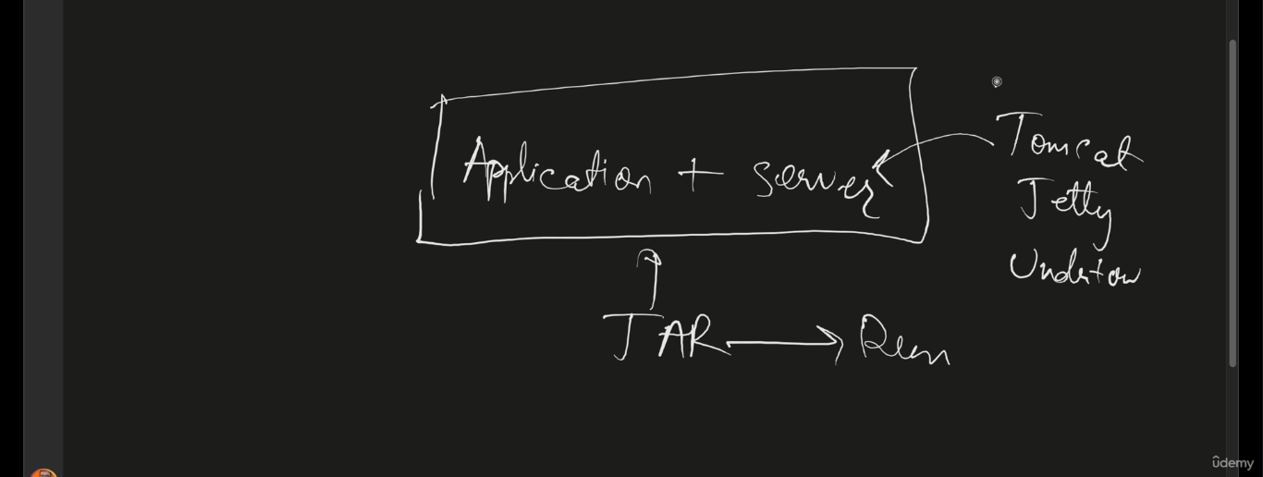

If you add spring boot web dependency by default tomcat server will come if you want to check open declare spring boot web dependency. 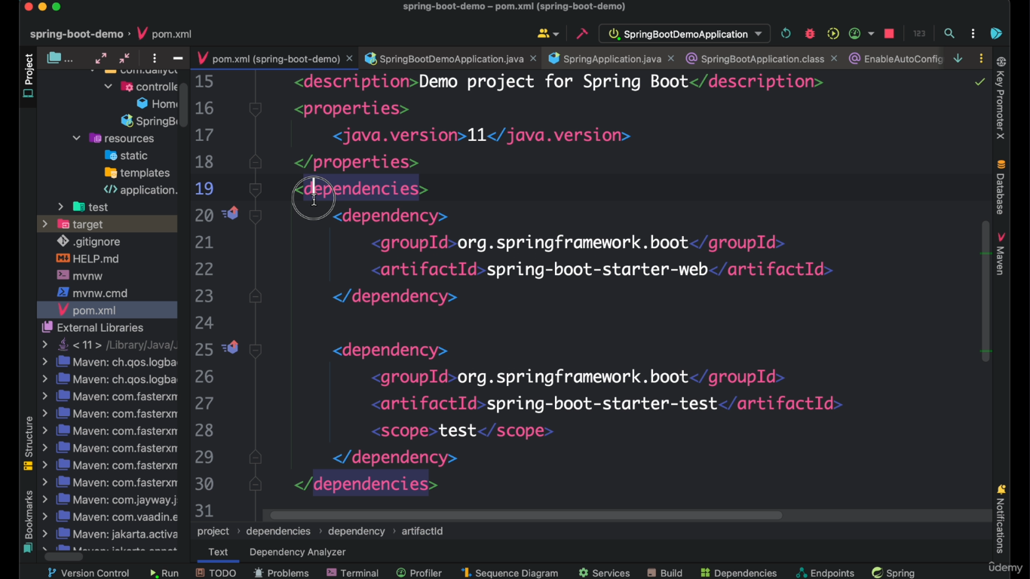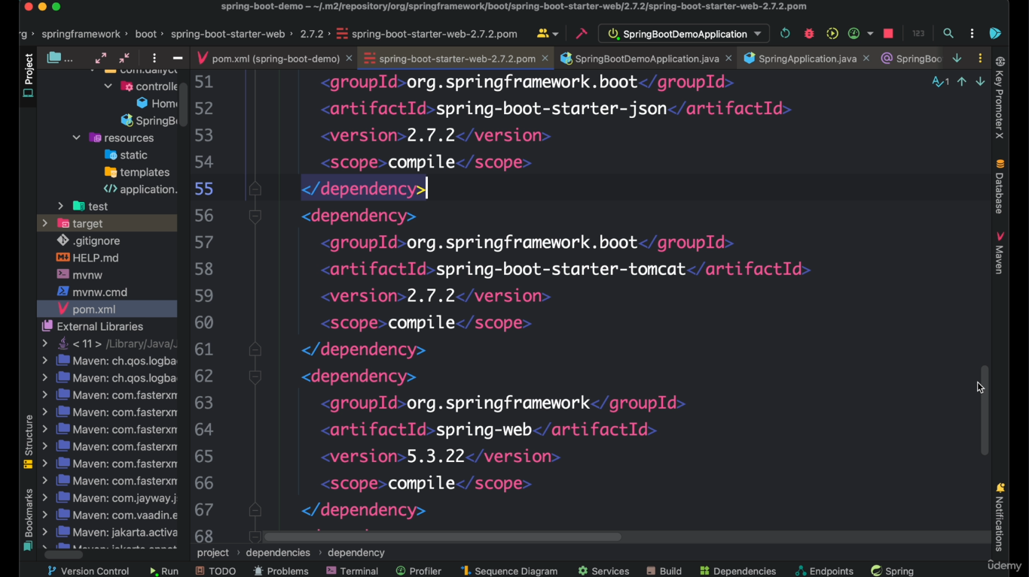

To add jetty server first remove tomcat . As tomcat contains in spring-boot-starter-web , add exclusion tag in that. Shown in below.

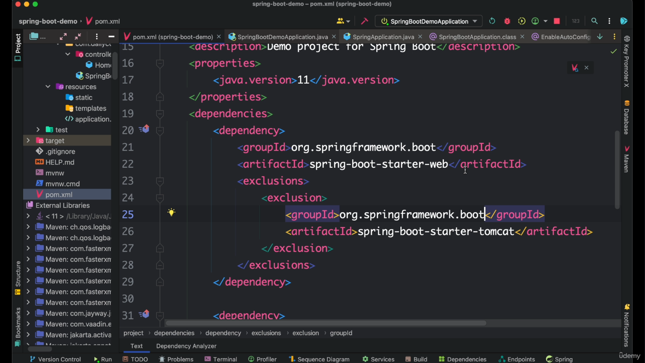

Now add jetty dependency in pom.xml show in below

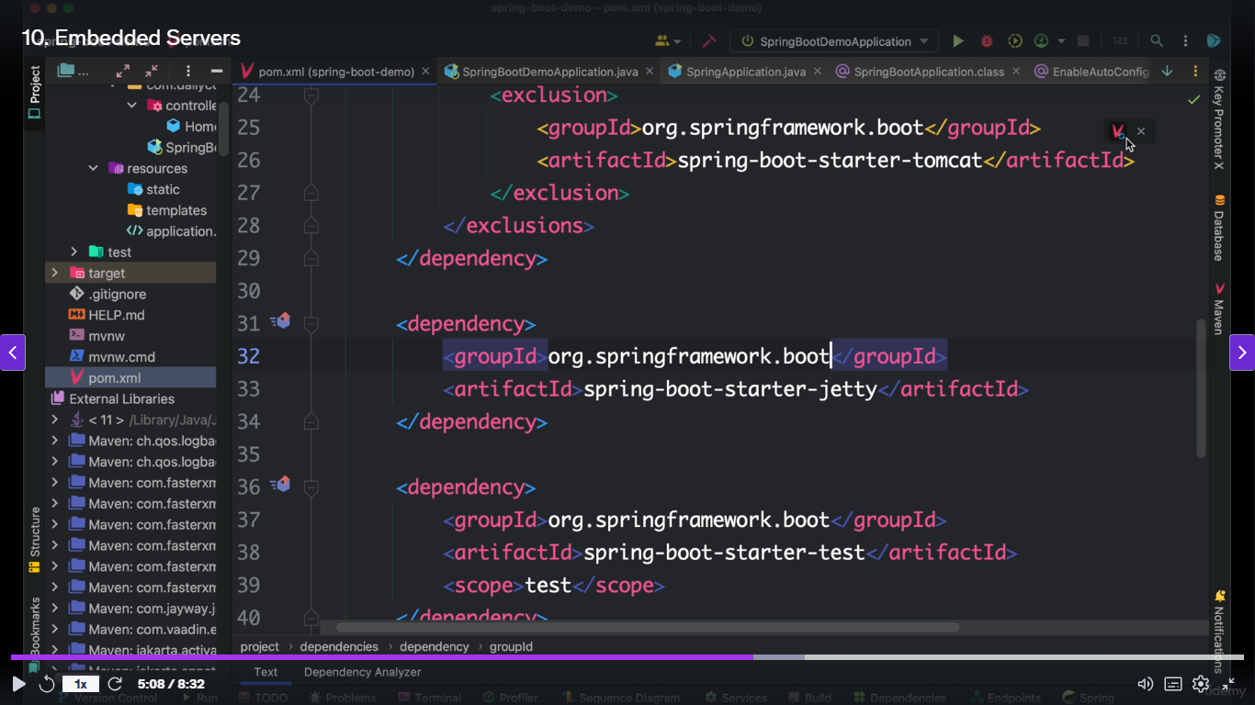

Now update project and restart the server then application will run in jetty server.

We can change the port number application.properties file

server.port=8081(default is 8080).

To exclude the tags we have plugin called Maven Helper if you want install it and restart the eclipse.then you find dependency analyzer where we have to exclude the dependencies shown in below.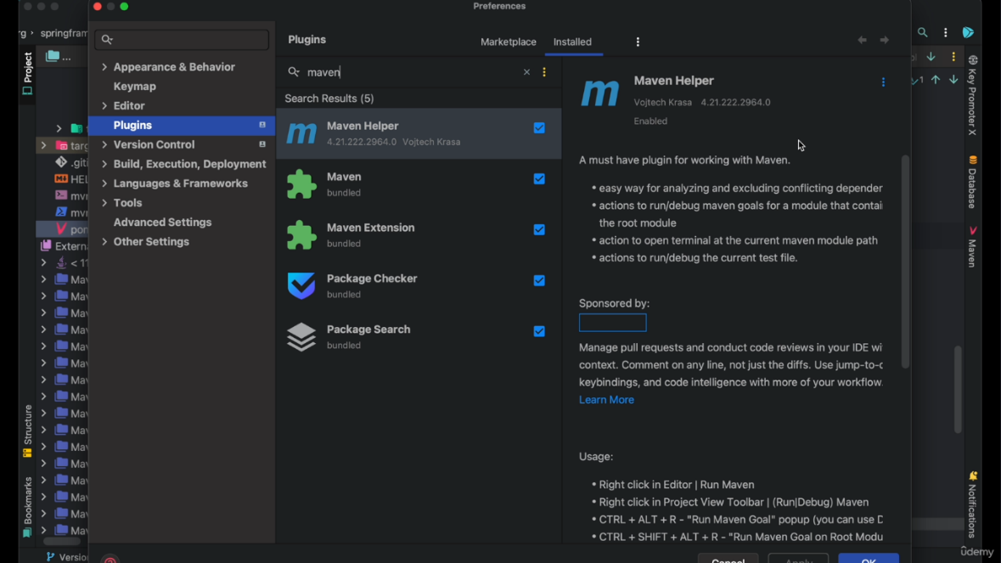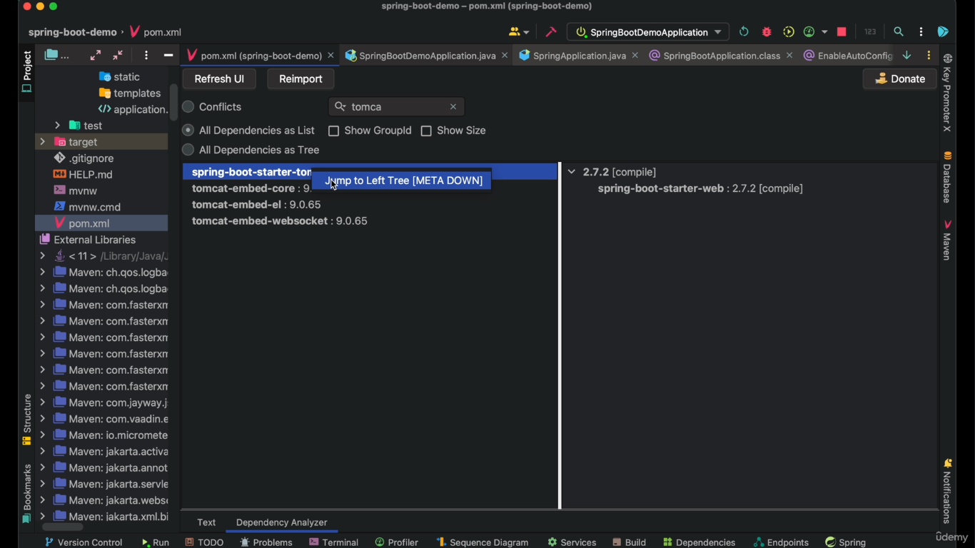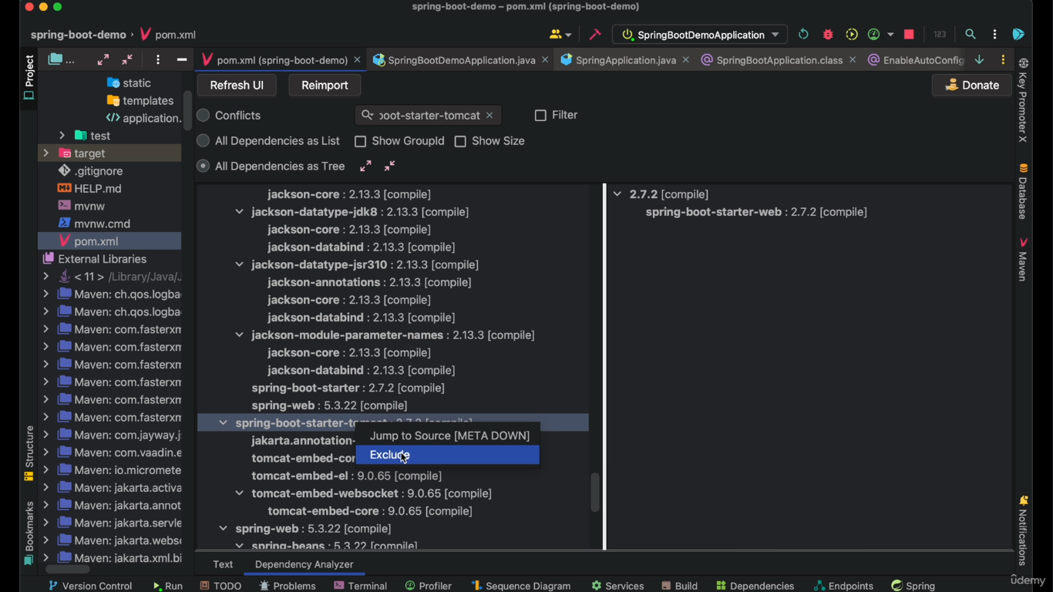

Spring boot Actuators:

It is a tool to monitor the spring boot application such as health,metrics,sessions etc,.

Actuators gives different end points to monitor our application.

We have to add dependencies in pom.xml

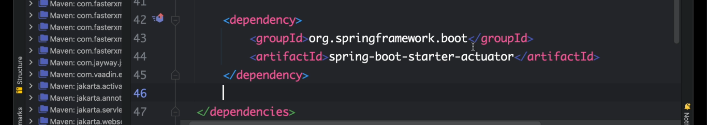

After update the project and run the application.then in console you can see the below

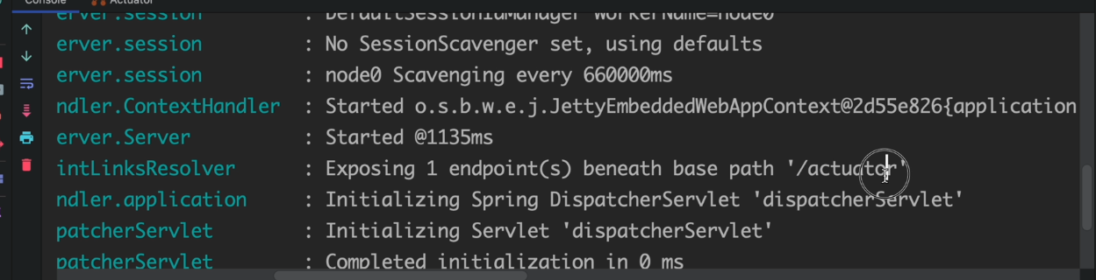

https//:localhost:8080/actuator/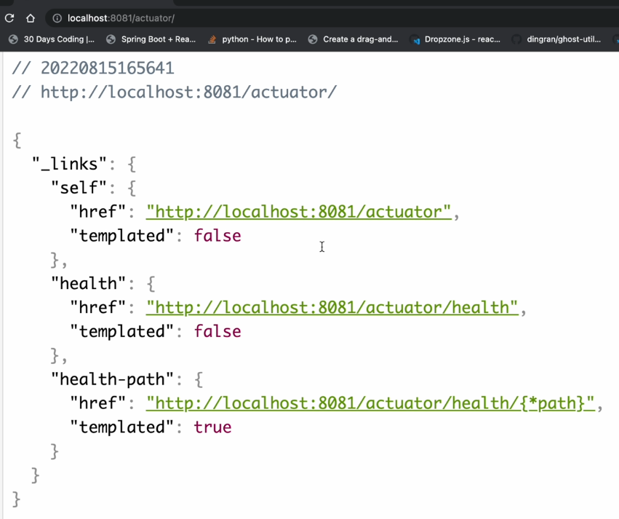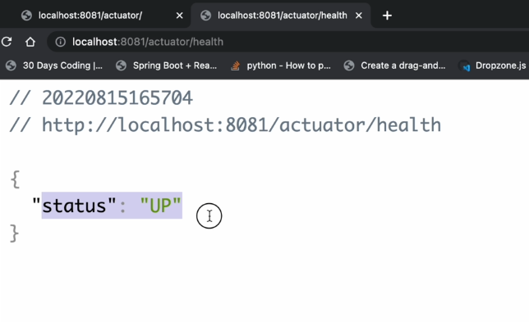

DevTools:

Used to build the project and deploy the project automatically.

In eclipse if you add the dependency that’s enough. shown in below.

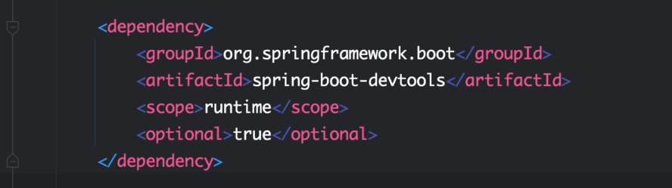

In intellige we have to do some changes as shown in below.

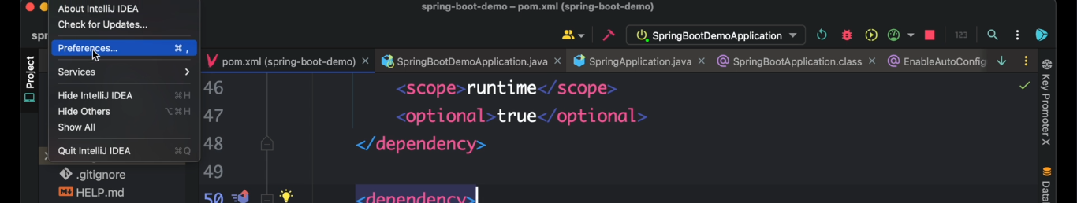

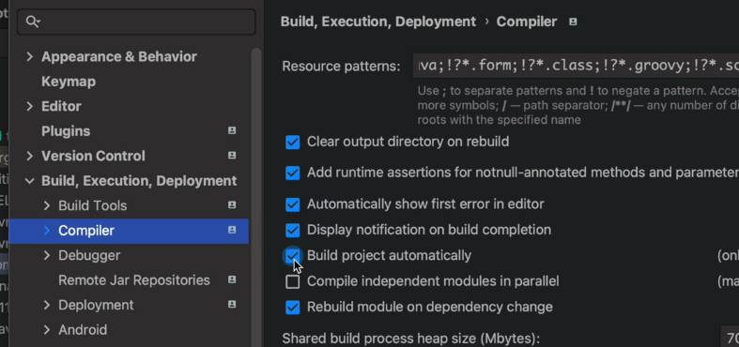

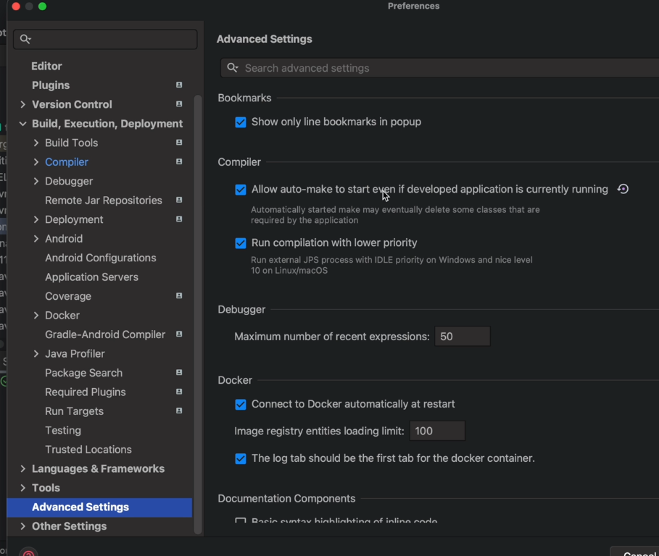

Web Services:

One application is communicates with another application using web services.

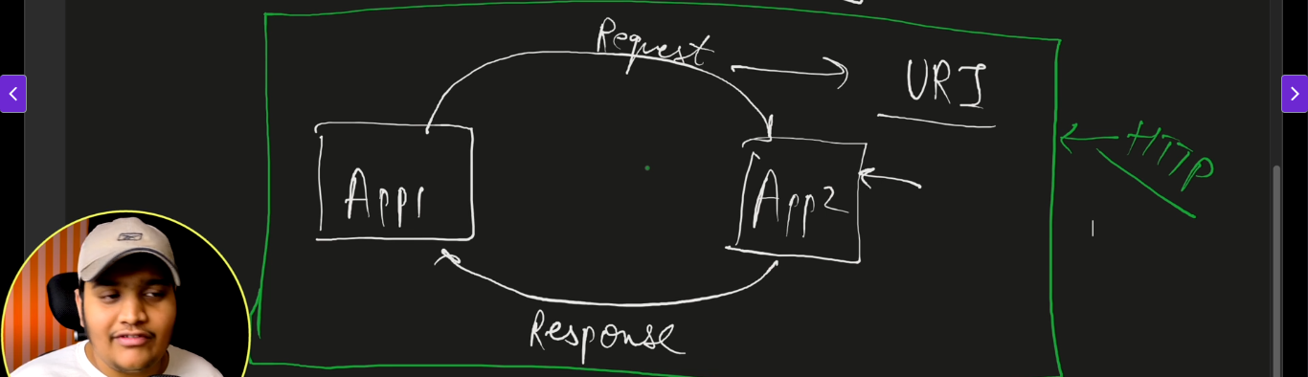

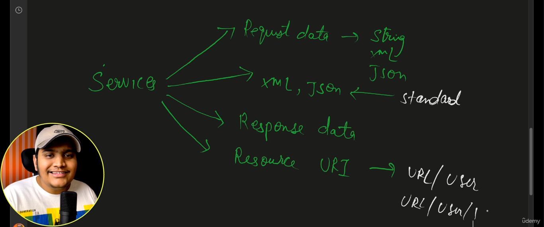

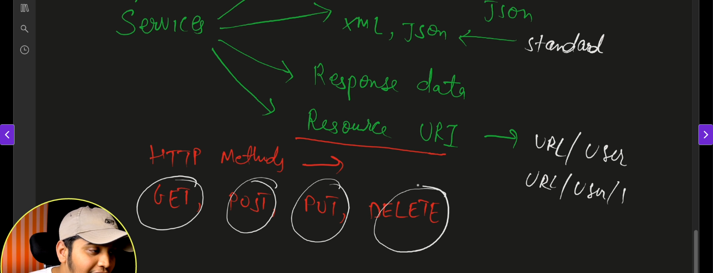

Web services are two types

1)REST

2)SOAP

**REST:** means Representational State Transfer.

Service can be representative based on the state and how data transfer will happen.

Two different languages are communicate through restfull web services.

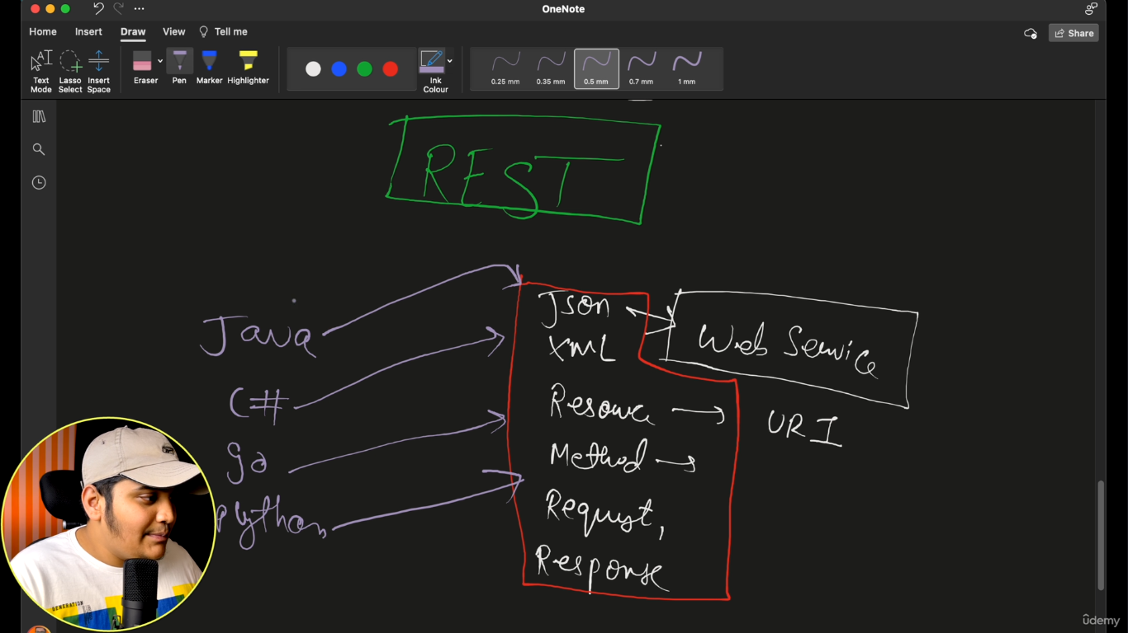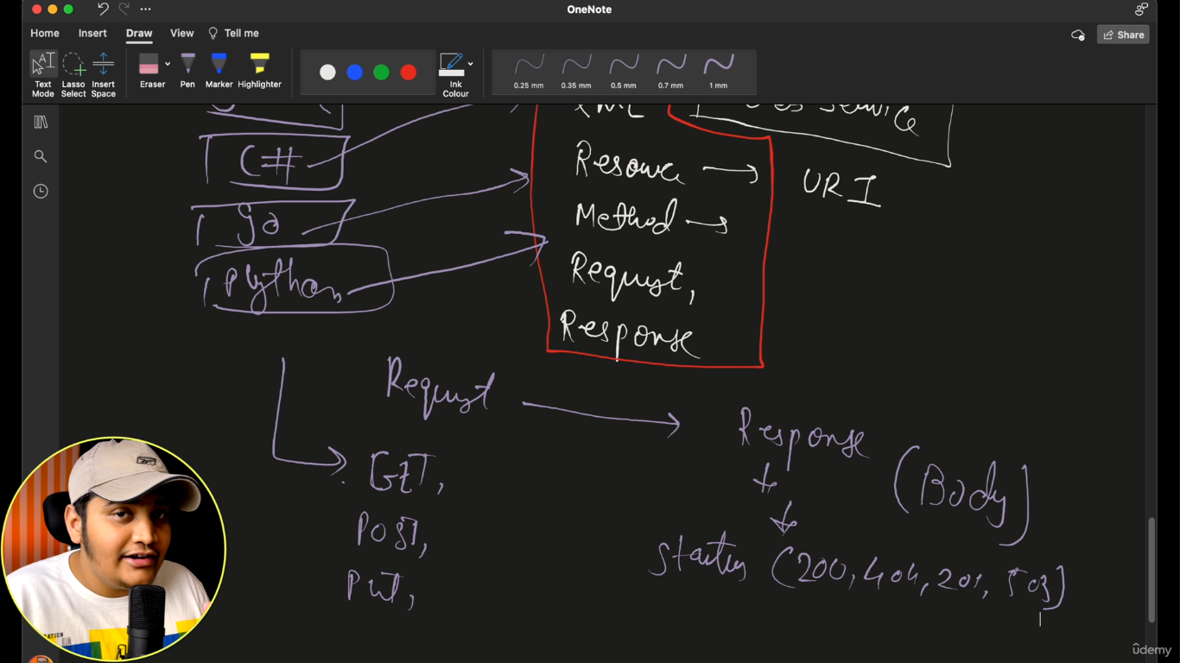

Status codes:

**🔵 1xx – Informational**

* **100 Continue** – The server received the request headers; the client should proceed with the request body.
* **101 Switching Protocols** – Server agrees to switch protocols (e.g., HTTP to WebSocket).
* **102 Processing** – Server has accepted the request but is still processing it.

**🟢 2xx – Success**

* **200 OK** – Request succeeded.
* **201 Created** – Resource was created successfully.
* **202 Accepted** – Request accepted but not yet processed.
* **204 No Content** – Success, but no content to return.

**🟡 3xx – Redirection**

* **301 Moved Permanently** – Resource moved permanently to a new URL.
* **302 Found** – Resource temporarily moved.
* **304 Not Modified** – Cached version is still valid; no need to resend.

**🔴 4xx – Client Errors**

* **400 Bad Request** – Malformed request.
* **401 Unauthorized** – Authentication required or failed.
* **403 Forbidden** – Client doesn't have permission.
* **404 Not Found** – Resource not found.
* **405 Method Not Allowed** – HTTP method not supported for the resource.
* **429 Too Many Requests** – Rate limiting in effect.

**🔴 5xx – Server Errors**

* **500 Internal Server Error** – Generic server error.
* **501 Not Implemented** – Server doesn't support the request method.
* **502 Bad Gateway** – Invalid response from upstream server.
* **503 Service Unavailable** – Server temporarily overloaded or down.
* **504 Gateway Timeout** – Server didn’t receive a timely response from upstream.

**Common HTTP Methods**

| **Method** | **Description** |
| --- | --- |
| **GET** | Retrieve data from the server (e.g., loading a webpage). **Safe** and **idempotent**. |
| **POST** | Submit data to the server to create a resource (e.g., form submission). Not idempotent. |
| **PUT** | Update or create a resource at a specific URL. **Idempotent**. |
| **PATCH** | Partially update a resource. Typically used for smaller updates. |
| **DELETE** | Remove a resource. **Idempotent** (repeating it doesn’t change the result). |
| **HEAD** | Like GET, but only returns headers (no body). Used to check if a resource exists. |
| **OPTIONS** | Describes the communication options for the target resource. Often used in CORS. |

@controller : make connection between java back end and java front end. Here we use @ResponsBody separately.it is designed for web pages(MVC)

@RestController: make connection between java back end and anagular,react . Here @ ResponsBody and @controller is there in @RestController.it is designed for RESTful APIs

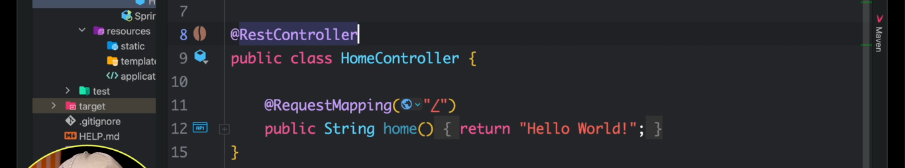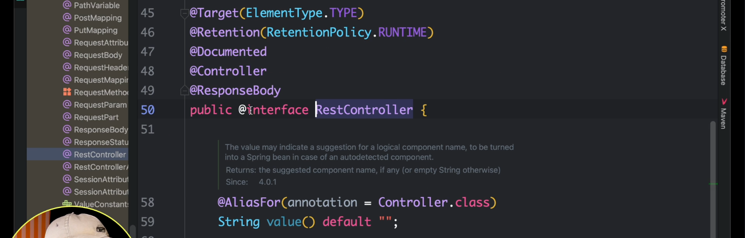

Return object example:

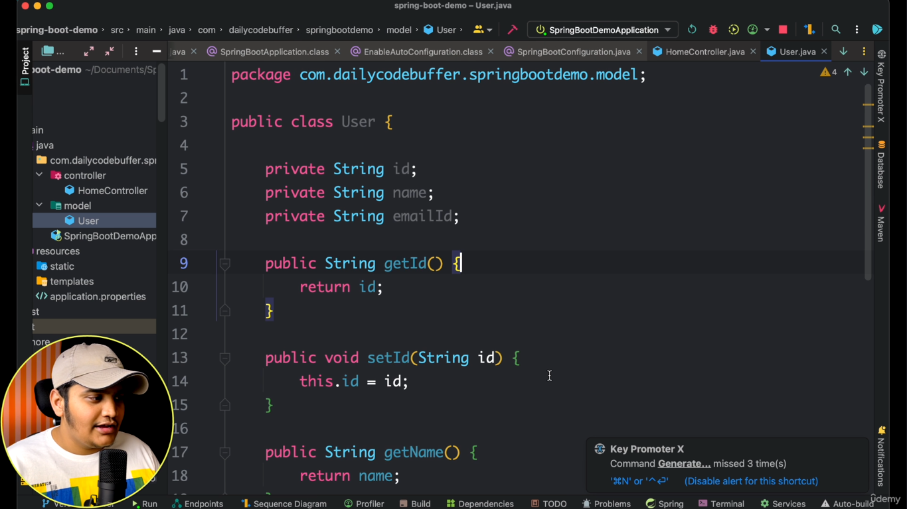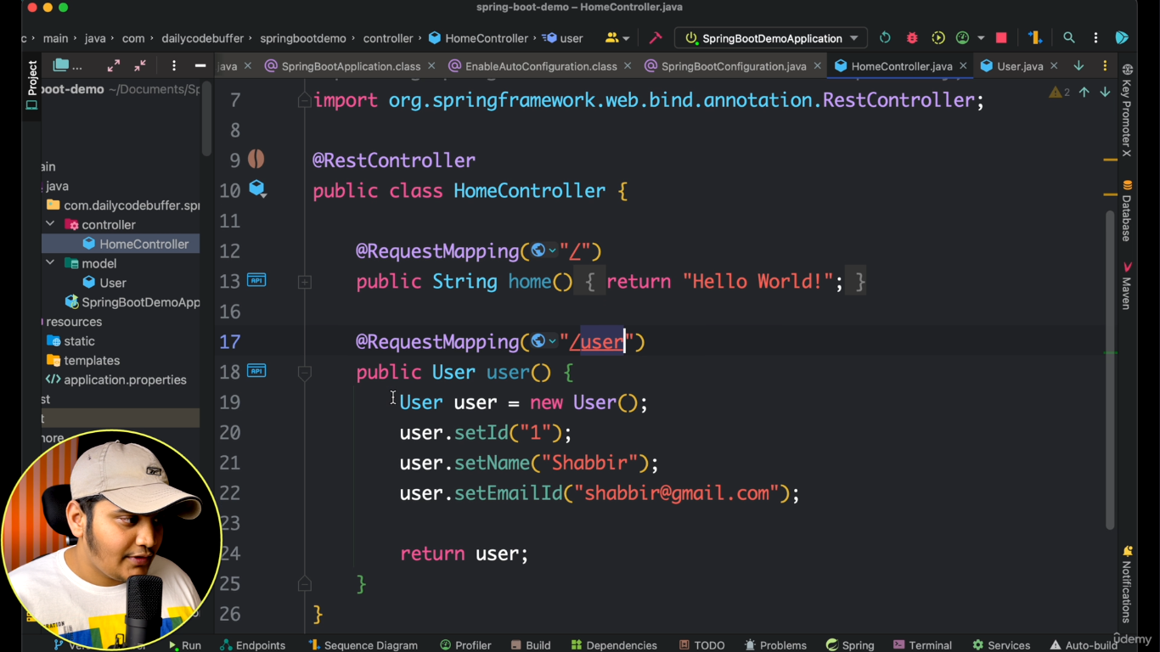

If we use the RequestMapping by default it supports GET. If you want to use RequestMapping for PUT ,POST ,DELETE and GET also you have to follow below syntax

@RequestMaping(value=”/user” method=RequestMethid.GET);

@RequestMaping(value=”/user” method=RequestMethid.PUT);

@RequestMaping(value=”/user” method=RequestMethid.POST);

@RequestMaping(value=”/user” method=RequestMethid.DELETE);

below are **shortcut annotations** introduced in Spring 4.3+ for above.

@GetMapping, @PutMapping, @PostMapping, @DeleteMapping if you open declare these annotations internally these contains @RequestMapping shown in below.

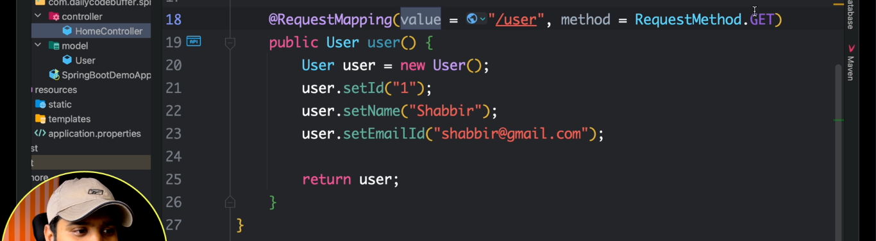

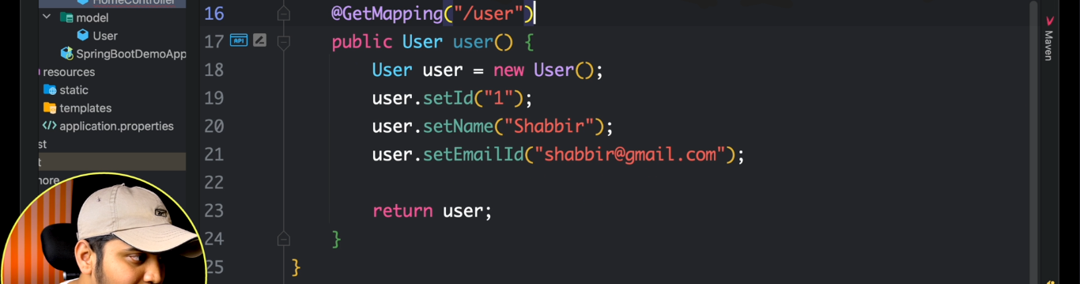

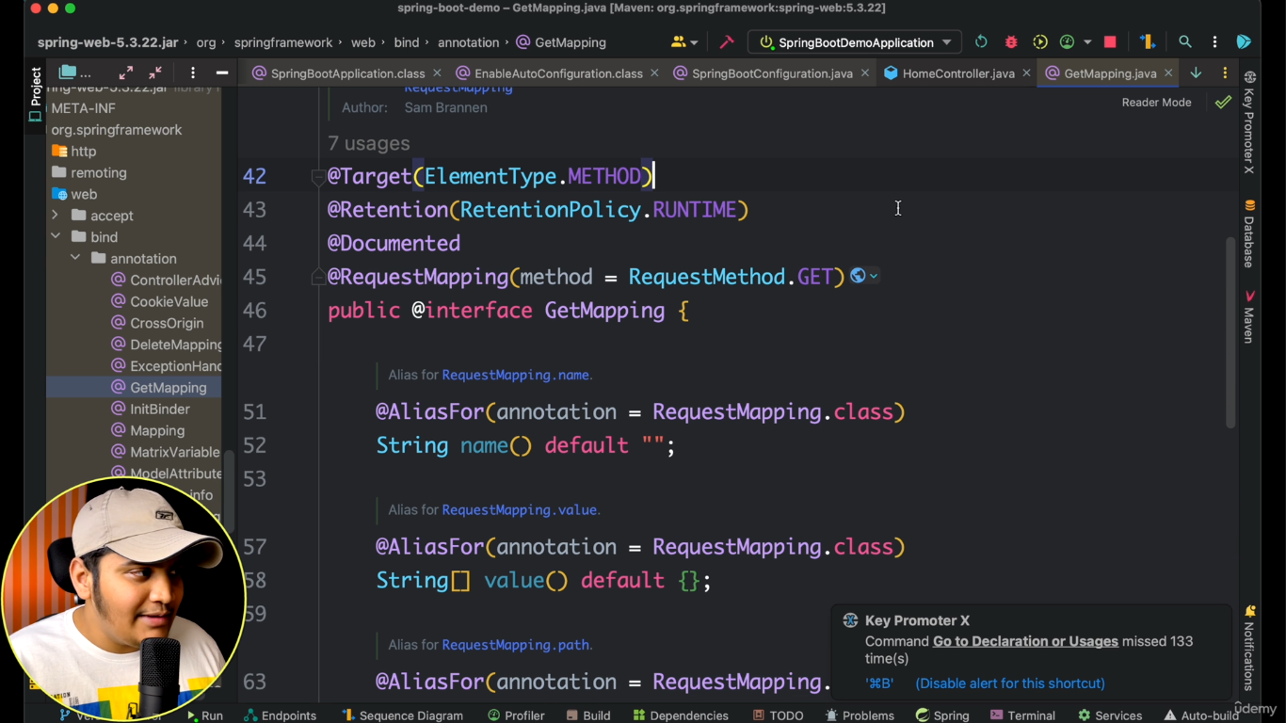

@PathVariable: whenever value from path is mandatory to get we use PathVariable.it is defined by /

Used to get value from url shown in below.



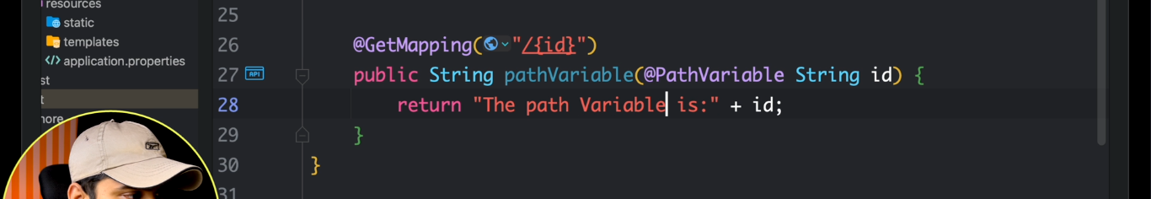

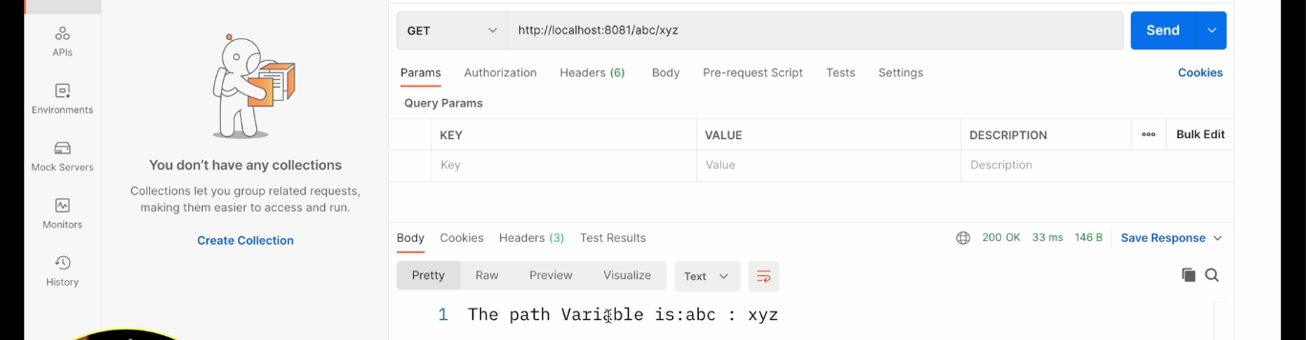

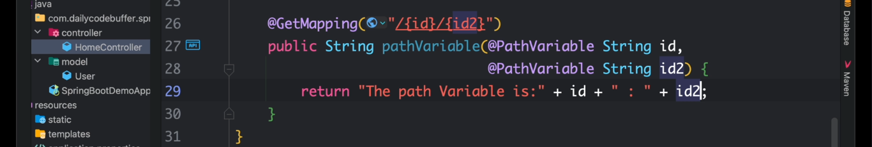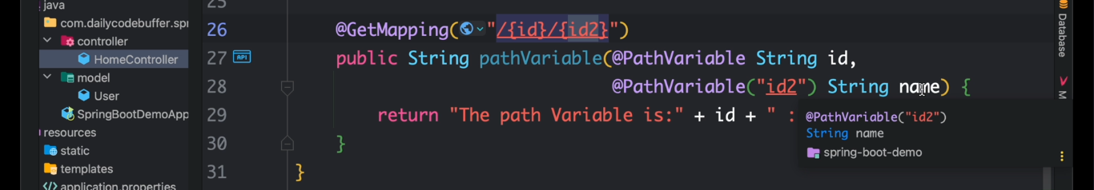

@RequestParam

whenever value from path is not mandatory to get we use @RequestParam.it is defined by using ?

